Table of Contents
WHAT IS THE MINIMUM I NEED TO START A PROJECT? 2
WHY DO MY IMAGES NEED TO OVERLAP? 3
WHY DO MY IMAGES NEED TO BE WITHIN 60 DEGREES OF NADIR? 3
WHAT IS A COORDINATE SYSTEM? 3
WHAT IS AN EARTH MODEL? 3
WHAT IS THE PLATFORM? 3
WHAT DO I DO FIRST? 3
CAN I SEARCH FOR A PROJECT OR FILTER THEM? 3
HOW CAN I CONTACT YOU? 4
WHAT ARE THE PRICING PLANS? 4
CAN I UNSELECT IMAGES ONCE I HAVE DROPPED THEM IN? 4
HOW LARGE CAN MY IMAGES BE? 4
DOES THE CAMERA USED EFFECT THE PROJECT? 4
DO MY IMAGES NEED TO HAVE SENSOR DATA? 4
WHAT IMAGE FORMATS ARE ACCEPTED? 5
CAN I UPLOAD IMAGES TAKEN WITH DIFFERENT SENSORS? 5
WHAT IS A GROUND CONTROL POINT (GCP)? 5
WHAT IS THE GROUND CONTROL POINT (GCP) FILE FORMAT? 5
WHAT IS A SENSOR? 5
WHY DOES THE CREATE SCREEN SAY MY SENSOR IS UNSUPPORTED? 5
WHY DO YOU NEED GPS DATA? 5
WHAT IS THE GPS FILE FORMAT? 5
WHY DOES MY SCREEN SAYS GPS DATA IS MISSING? 6
CAN I GIVE A CUSTOM FOCAL LENGTH FOR MY SENSOR? 7
CAN I GIVE A CUSTOM GPS ACCURACY FOR MY SENSOR? 8
WHAT IS GROUND SAMPLING DISTANCE (GSD)? 9
WHAT IS ROLLING SHUTTER AND WHY DOES IT MATTER? 9
MY SENSOR USES ROLLING SHUTTER, IS THERE ANYTHING I CAN DO? 10
HOW MANY GROUND CONTROL POINTS DO I NEED TO CORRECT? 10
ONE OF MY GROUND CONTROL POINTS IS NOT VISIBLE IN THE ADJUSTOR. WHAT SHOULD I DO? 10
ARE THERE ANY SHORTCUTS TO MAKE THIS PROCESS FASTER? 10
WHY AM I FORCED TO BE ON THE ADJUSTOR PAGE? 10
THE GEAR JUST KEEPS SPINNING. WHAT SHOULD I DO? 11
WHY DO I HAVE TO RE-DO THE GROUND CONTROL POINT CORRECTION? 11
MY PROGRESS HASN'T CHANGED FOR A LONG TIME. IS IT FROZEN? 11
CAN I ORDER NEW PRODUCTS WHILE OTHERS ARE PROCESSING? 11
WHAT IS A DENSE POINT CLOUD? 11
WHAT IS A SURFACE MODEL? 11
WHAT IS A DIGITAL ELEVATION MODEL? 11
WHAT IS AN ORTHOIMAGE? 11
WHAT IS A CONTOUR MAP? 11
WHAT IS A PROJECT REPORT? 12
WHAT IS A BUNDLE ADJUSTMENT? 12
CAN I EXPORT MY DATA PRODUCTS? 12
WHAT IS A LAS FILE? 12
WHAT IS A GEOTIFF FILE? 12
WHAT IS A DXF FILE? 12
WHAT IS A JPG FILE? 12
WHAT IS A JGW FILE? 12
WHAT IS A PDF FILE? 12

WHAT IS THE MINIMUM I NEED TO START A PROJECT?
To start a project, all you need is a set of at least 10 images taken from a drone or other aerial source that are geotagged (have gps coordinates embedded in the pictures). Almost all drones these days have gps coordinates in their images, so you probably just need your images. The matter in which the images are taken will affect how well the dense point cloud and other products are generated. You should try and take each photo with a 70% side and forward overlap, and all images should be within 60 degrees of nadir. Here is an illustration to explain nadir.
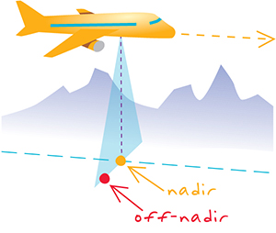

WHY DO MY IMAGES NEED TO OVERLAP?
Your images should have around 70% side and forward overlap with each other for best results. 70% is generally the sweet spot, as less can cause incomplete reconstructions and more is a waste of data and can actually produce worse results.

WHY DO MY IMAGES NEED TO BE WITHIN 60 DEGREES OF NADIR?
This is to minimize distortions of features in your images that result due to off-axis projections.

WHAT IS A COORDINATE SYSTEM?
A coordinate system is a way to get very precise locating for region-specific areas. The earth is not a perfect sphere and different areas of the earth have different curvature to them. You can select the appropriate coordinate system when creating your project. You should use the coordinate system appropriate for the zone in which your imagery resides. You can select a UTM zone, or a state plane coordinate system.

WHAT IS AN EARTH MODEL?
You can select the appropriate earth model when creating your project. The earth model defines a standard coordinate system and surface geometry that can be used to reference locations on the Earth's surface.

WHAT IS THE PLATFORM?
The platform represents how your imagery was obtained. You can select from drone, airplane, or other.

WHAT DO I DO FIRST?
Getting started is easy. You'll need to have aerial or drone imagery. Your imagery should exhibit 50% overlap and be within 60 degrees of nadir to allow accurate processing.
- Create a new project.
- Give your project a name.
- Select the default units to use in the initial set of data products.
- Select the appropriate image platform.
- Select your images by dragging images onto the upload area, or browse for the images on your computer.
- Choose the coordinate system.
- If your images don't have gps data embedded, you should drop in your GPS CSV file now.
- If you have ground control points add the file with them now.
- Select the orange 'create' button in the bottom right.
- Check the checkbox ensuring the coordinate system and unit of measure are correct.
- Click 'create' and then leave the browser open while the upload is running.
- If you added ground control, the correction process will start around 85% completion of the bundle adjustment.

CAN I SEARCH FOR A PROJECT OR FILTER THEM?
You can click the Filter link above projects to show filtering options. You can filter by name and location.

HOW CAN I CONTACT YOU?
The best way to reach us is via the chat box at the bottom left corner of your screen. Simply enter your email and hit Start to chat with us. You can also email us at sales@pixelement.com.

WHAT ARE THE PRICING PLANS?
With your purchase of Carlson PhotoCapture - Standalone, you are entitled to receive free updates for a year from date of purchase. To continue to receive these updates after this date, a yearly fee of 10% of the current list price of a new seat of the software is required. This maintenance fee is optional – failure to maintain your software will not stop the software from working, but you will no longer receive updates. The maintenance cost ceiling is 50% of the current list price, even if you have not maintained your software for 6 or more years. The current list price is $3500, yearly maintenance is $350.

CAN I UNSELECT IMAGES ONCE I HAVE DROPPED THEM IN?
Yes, you can draw a polygon around the images you wish to keep, or click toggle individual images on and off. In the example below the blue images would be kept and the red would be ignored.
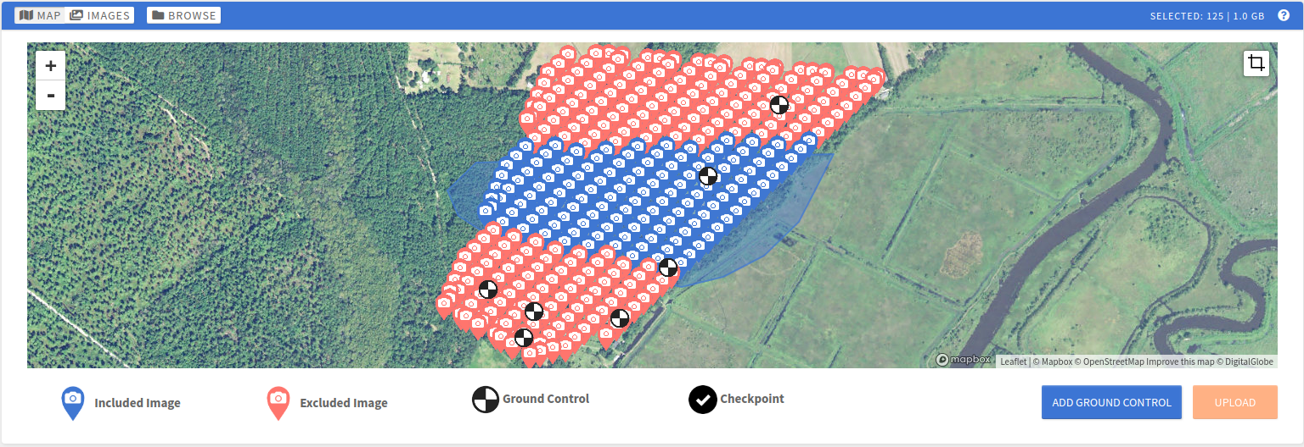

HOW LARGE CAN MY IMAGES BE?
We accept all image sizes, but normally the images we process are around 8-40MP. For high resolution cameras taking 50MP+ images, you may want to contact us first.

DOES THE CAMERA USED EFFECT THE PROJECT?
Yes and no. The model of your camera, whether it be Sony, Samsung, etc should not affect the process as long as we have your sensor in our database (contact us if we don't and we'll add it). The primary stipulation for cameras if that we do not accept fish-eye lenses. The size of your images, i.e., the number of megapixels your camera is rated at, will affect the process. Higher resolution cameras producing larger images will produce finer grain of details in the output. That being said, they will subsequently take longer to process and will use up more of your processing capacity.

DO MY IMAGES NEED TO HAVE SENSOR DATA?
Your images must have the make and model along with focal length and gps location embedded in the exif data. Don't worry though, pretty much all images already come with this information and all you need to do is drag and drop them in. If you get any errors on the interface that you do not know how to fix, feel free to contact us.

WHAT IMAGE FORMATS ARE ACCEPTED?
JPG currently. Your files must end in .jpg or .JPG, not JPEG. We plan on adding support for GeoTiff ‘s in the future.

CAN I UPLOAD IMAGES TAKEN WITH DIFFERENT SENSORS?
You can upload images taken with different sensors, but you can only select one set of images with the same sensor to process for a given project.

WHAT IS A GROUND CONTROL POINT (GCP)?
A ground control point is a visible point of reference that has been measured on the land for the GPS position. The actual object you use for reference as a GCP does not matter much as long as it is in contrast with the surrounding area and is not shiny. To use ground control points in our software simply place the GCPs spread around your area of interest and record the x,y,z coordinates either your output coordinate system, or in lat, long, elevation (m). Upload a text file with the values and follow instructions on the 'Add Ground Control' screen for expected file formats.

WHAT IS THE GROUND CONTROL POINT (GCP) FILE FORMAT?
We accept many different file types for ground control. Once you have added your images to the scene, you can choose from LandXML, CRD, or a custom text file. Within the text file upload there are 3 options all comma separated with new lines for each GCP:
Description of GCP, latitude (degrees), longitude (degrees), elevation (meters)
Description of GCP, Northing, Easting, Elevation (in coordinate system unit of measure)
Description of GCP, Easting, Northing, Elevation (in coordinate system unit of measure)

WHAT IS A SENSOR?
A sensor represents the element on your drone or camera used to capture images. We support most common sensors. If you have a sensor that we don't support, please contact us.

WHY DOES THE CREATE SCREEN SAY MY SENSOR IS UNSUPPORTED?
We support most common sensors already, but if your sensor isn't recognized, please contact us and we will add it as quickly as possible

WHY DO YOU NEED GPS DATA?
We use your GPS data to tie the images to the real world, and give all of your data products accurate measurements.

WHAT IS THE GPS FILE FORMAT?
The extension of the gps file can be either .txt, or .csv. The format of the file should be a comma separated file with the exact same number of lines as images taken and each line must have 4 values in the following format
Name of corresponding image.jpg, latitude (degrees), longitude (degrees), altitude (meters)

WHY DOES MY SCREEN SAYS GPS DATA IS MISSING?
You are one of the unlucky few that have a camera that does not automatically embed exif GPS data. You will need to embed this data in the photos yourself in order for the project to work. If you have no idea what any of this means then you can contact us and we will be glad to help.

CAN I GIVE A CUSTOM FOCAL LENGTH FOR MY SENSOR?
Yes. When you are finish dropping in your images and any ground control points/GPS locations, select "done". On the Confirm Create dialog box there is a field called "advanced fields" click this to reveal the area where you can enter the focal length of your sensor in mm.
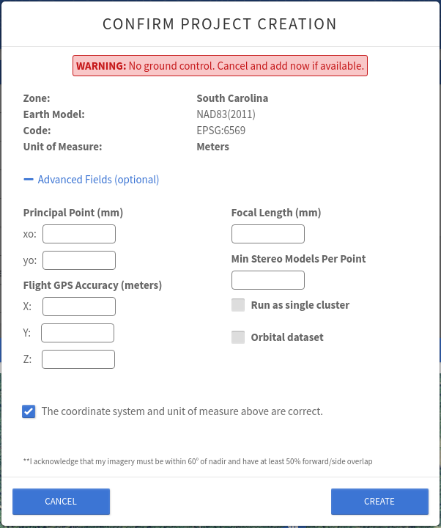

CAN I GIVE A CUSTOM GPS ACCURACY FOR MY SENSOR?
Yes. When you are finish dropping in your images and any ground control points/GPS locations, select "done". On the Confirm Create dialog box there is a field called "advanced fields" click this to reveal the area where you can enter the flight GPS accuracy in meters.

WHAT IS GROUND SAMPLING DISTANCE (GSD)?
The ground sampling distance represents the linear length on the ground of a pixel. The ground sampling distance is inversely proportional to the resolution. As one increases, the other decreases. The ground sampling distance is dependent on camera altitude, camera angle, terrain, and other factors.

WHAT IS ROLLING SHUTTER AND WHY DOES IT MATTER?
Rolling shutter is best explained visually. Below on the left is how most cameras work, capturing the image in its entirety in one shutter, whereas rolling shutter takes the image in sections over a period of time.
Global Shutter
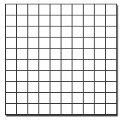

Rolling Shutter

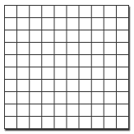
So what? Why should this matter? Well, there are a couple reasons. The first is that we need to have an exact camera position for when the images were taken in order to accurately reconstruct the 3D scene. Rolling shutter is taken over a period of time, so there is no exact camera position. The second is again best explained with a gif.
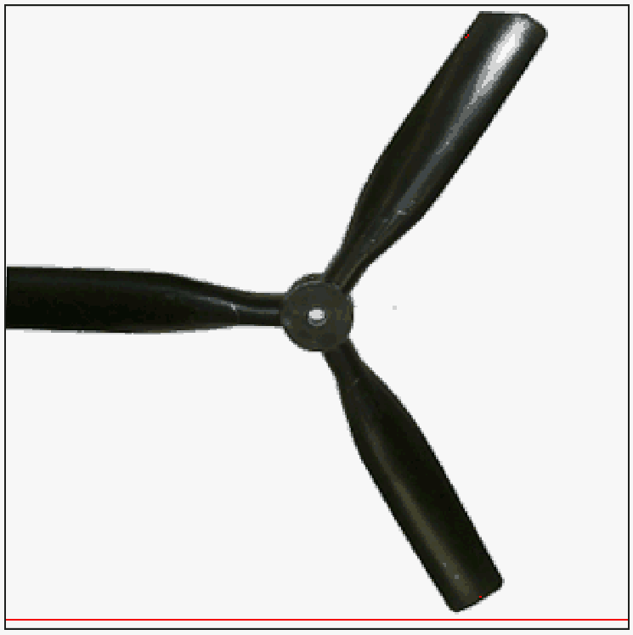

Taking an image over time can produce warping in object in the scene which will again make the accuracy of the data products worse than when using global shutter.

MY SENSOR USES ROLLING SHUTTER, IS THERE ANYTHING I CAN DO?
Many cameras will have the option to switch to global shutter, and if this exists you should simply pick this option. If your camera only uses rolling shutter, there is a fairly easy fix for it. When flying your path, make sure that your drone is still during the actual capturing of images, and this should result in images that emulate global-shutter.

HOW MANY GROUND CONTROL POINTS DO I NEED TO CORRECT?
The more GCPs you correct the better. The absolute minimum to correct is 2 but for optimal results you should correct as many as possible.

ONE OF MY GROUND CONTROL POINTS IS NOT VISIBLE IN THE ADJUSTOR. WHAT SHOULD I DO?
If you cannot see the ground control point in the adjustor, you may need to expand the image to the full version. We default to showing the cropped version for improved network speed. If you expand the image and still do not see the ground control point, simply skip to the next appearance.

ARE THERE ANY SHORTCUTS TO MAKE THIS PROCESS FASTER?
Yes! Simply click on the target location in the image and then right click to accept and go to the next point.

WHY AM I FORCED TO BE ON THE ADJUSTOR PAGE?
When you add GCPs, you have to finish the correction before anything else can happen. We force you to look at this page so that you know that you have to interact in order to continue the project's progress.

THE GEAR JUST KEEPS SPINNING. WHAT SHOULD I DO?
After finishing the correction process, you may see a spinning gear indicating that things are happening in the background. Usually, this process will be short, but occasionally the network can be very busy. So, hold tight and be patient, checking in on the data page with the progress bars to see if anything is happening. Let us know if it has been stuck there for over a half hour.

WHY DO I HAVE TO RE-DO THE GROUND CONTROL POINT CORRECTION?
Sometimes, when clicking and right clicking through the points, you may accidentally accept a correction that is incorrect. The most common situation is that you have multiple GCPs on your screen and you clicked the wrong one. That will cause the system to fail in the backend. Don't worry. We give you infinite tries to place those markers in the right spot. Go through each of your points and double check them for accuracy, skipping ones you are not sure about.

MY PROGRESS HASN'T CHANGED FOR A LONG TIME. IS IT FROZEN?
If your progress bar has been stuck for hours on at the same spot, then you should contact us via the chat window in the bottom left. Something unexpected probably happened. If your progress bar is moving slowly but surely then hold tight, your project may have an area with a dense cluster of images that takes longer to complete

CAN I ORDER NEW PRODUCTS WHILE OTHERS ARE PROCESSING?
No, you will need to wait until the product you are ordering is finished.

WHAT IS A DENSE POINT CLOUD?
A dense point cloud is a collection of points in three-dimensional space, each with an assigned colour value. The points represent the surfaces of the terrain and features on the ground.

WHAT IS A SURFACE MODEL?
A surface model is a 3D model of the environment represented by the images you upload. Using the orthoimage and the digital elevation model, an accurate surface model can be generated. You can then explore the surface model freely from any perspective.

WHAT IS A DIGITAL ELEVATION MODEL?
The digital elevation model assigns elevation to each point on the surface represented by your images.

WHAT IS AN ORTHOIMAGE?
An orthoimage stitches your images together and corrects them so that the image has uniform scale. That is, there are no distortions. The creation of the orthoimage relies on having a digital elevation model of the area.

WHAT IS A CONTOUR MAP?
A contour map lets you visualize slopes and elevations. The map displays curves that represent points on the ground that have the same elevation.

WHAT IS A PROJECT REPORT?
The project report is a summary of the project in an easy-to-read PDF format. It describes the camera, bundle adjustment results and selected project settings, and provides at look at the elevation model, orthoimage, and contour map.

WHAT IS A BUNDLE ADJUSTMENT?
For best results, you need to upload images that have 50% overlap of the neighbouring area. This means different images show the same features from different perspectives. Bundle adjustment is the process of finding the best reconstruction of your images in order to create the most accurate data products. This relies on non-linear least squares fit methods, where the error between actual and projected images is minimized.

CAN I EXPORT MY DATA PRODUCTS?
After your data products have completed processing, you can export them. You can export:
- Corrected images from your upload
- Bundle adjustment report as a text file
- Dense point cloud as a LAS file
- Surface model as an OBJ file
- Digital elevation model as a GeoTiff + TFW or JPG + JGW
- Orthoimage as a GeoTiff + TFW or JPG + JGW
- Project report as a PDF file

WHAT IS A LAS FILE?
A LAS file is used to store data collected by remote sensors.

WHAT IS A GEOTIFF FILE?
A GeoTiff file is a TIFF image file with additional georeferencing data, such as the map projection and coordinate system relevant to the image.

WHAT IS A DXF FILE?
A DXF file is a common file format for spatial data.

WHAT IS A JPG FILE?
A JPG file, also known as a JPEG file, is a very common file format for graphics.

WHAT IS A JGW FILE?
A JGW file is a sidecar text file to accompany the JPG and is also known as the world file. It contains geographical information.

WHAT IS A PDF FILE?
A PDF file is Adobe's Portable Document Format and is a very common file format for viewing readable and printable content such as text and graphics. You can view PDF files in your browser, with bundled PDF readers on macOS and Windows, or with Adobe's PDF reader software.

